COSC 4377 – Networking - Kevin B Long

# interlocking-uh-m-186.eps

**Solutions to** Homework #3

Summer 2023

100 pts possible

Name:      ID #:

1. Mark each of the following facts which are True. If you leave your document in a mode where Word shows you a checkbox, then check the box if it’s true, leave it blank if not. Otherwise, if you abandon forms mode, you should be able to type T or F in front of every question.

Use your judgment. Few things are black and white. If you feel that a statement is generally more true than false, mark the answer as True. Do not let a “corner case” prevent you from finding a statement to be generally true. 51% true is good enough for True.

1. TCP and UDP work to share the connection equally among all streams of packets
2. TCP Reno and Tahoe use an additive increase / multiplicative decrease model of sizing windows
3. Usually an application has enough data to fill the entire transmission window repeatedly
4. Encapsulation is when you put the output of a layer into the payload of another packet in the same layer
5. Tunneling is when you put the output of a layer into the payload of another packet in the same layer
6. Tunneling can hide the header of a packet so that routers and other devices along the way to not inspect, change or act on them
7. NAT is general-purpose enough that it will translate not just private source IP addresses from a network before passing it through to the other side, but public addresses also.
8. In wireless networks, if you are within range of the central access point, then you are within range of all other senders.
9. Wired network standards specify the longest cable permitted so that the round-trip time on the wire is no longer than the time to transmit the smallest allowed packet.
10. Traditional routing is like asking a traffic cop at every intersection for the next street to use. Software-Defined Networking is like having Waze running that has the entire route in mind at all times.
11. Network Address Translation

This problem is based on the Network Address Translation interactive exercise [here](https://gaia.cs.umass.edu/kurose_ross/interactive/nat.php) (<https://gaia.cs.umass.edu/kurose_ross/interactive/nat.php>).

Your browser sends an HTTP packet from 128.249.27.1 (instead of 10.0.1.x) to [www.uh.edu](http://www.uh.edu) (129.7.97.54) on port 80.

* Your source port assigned by the OS is random, equal to (your ID mod 1000) + 5000. First, give that port number here:
* The number of bits in the network part of your overall network block assigned by the Internet Assigned Numbers Authority (IANA) is (your ID mod 10) + 4. What is it?
* You are part of a subnet of this network. The number of bits in the network part of your specific IP’s address is (your ID mod 16) + 15. What is it?
* Your address is translated to the one shown in the simulator (on the web page at the link above), but we will set your randomly-assigned source port number to   
  (your ID mod 1000) + 8000. What is that?

1. Show the four values in the header at point 2 in the diagram:

Source IP:

Destination IP:

Source Port:

Destination Port:

1. On the way back, your packet is fragmented and arrives as several packets at point 3 in the diagram. They eventually arrive back at your computer, passing as the last step through the NAT router at the edge of your LAN.   
   For the first fragment to return to your LAN, what are the four values in the header at point 4?

Source IP:

Destination IP:

Source Port:

Destination Port:

1. Do the values in the other fragments match these values? Y/N

Open the subnet generator at <https://tidalcloud.com/subnet-builder/>. Enter the IP address you were assigned inside your LAN, 128.249.27.1. For the /n required by the page, enter the first n you calculated above, the number of bits in the network part of your overall network address. This is called the “slash” value. So /10 is “slash 10”.

1. What is the network IP address for your network?
2. What is the broadcast IP address for your network?
3. How many hosts can this network support? What is that number?

*Insert a screen capture showing your answer here. You may have to click in the blue image to the right of the IP address, like I did here:*

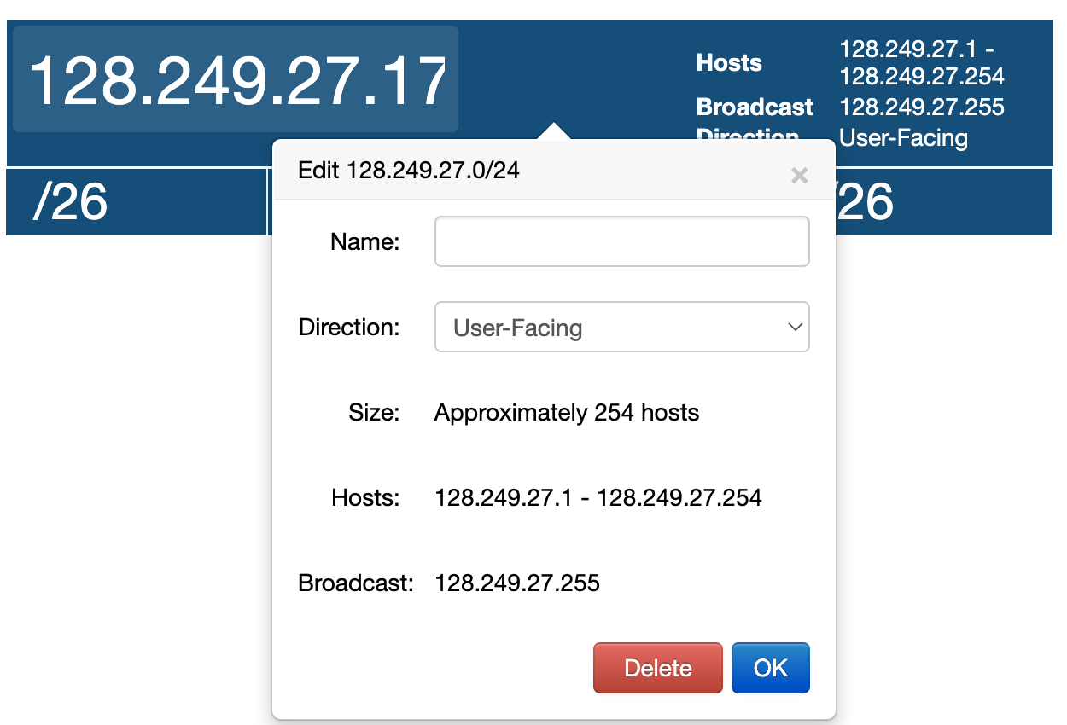

< Insert your image here>

1. Using the blocks on the right, burrow down into your range of network IP addresses dividing up the blocks in halves, fourths, or eighths until you create one that contains your specific IP address, and with exactly the value for n in /n that you calculated as yoru second number above, the number of network bits in the subnet part of your address. It will always be a number larger than the first.

The IP address you used inside your network is part of a subnet that is a /n, where n is the number of bits in the network part of your address.

1. What is the network address for this subnet?
2. What is the broadcast address for this subnet?
3. How many hosts can be assigned addresses on this subnet?         
   *(exclude the network number and broadcast address, just as the subnet tool excludes. In other words, go with their number of hosts)*
4. Include a screen snapshot showing the values with the pop-up window displaying the answers. Remember, you need to click on the exact subnet. For example, here is one showing the details for 128.249.27.17 (not the same address as the one you were given):

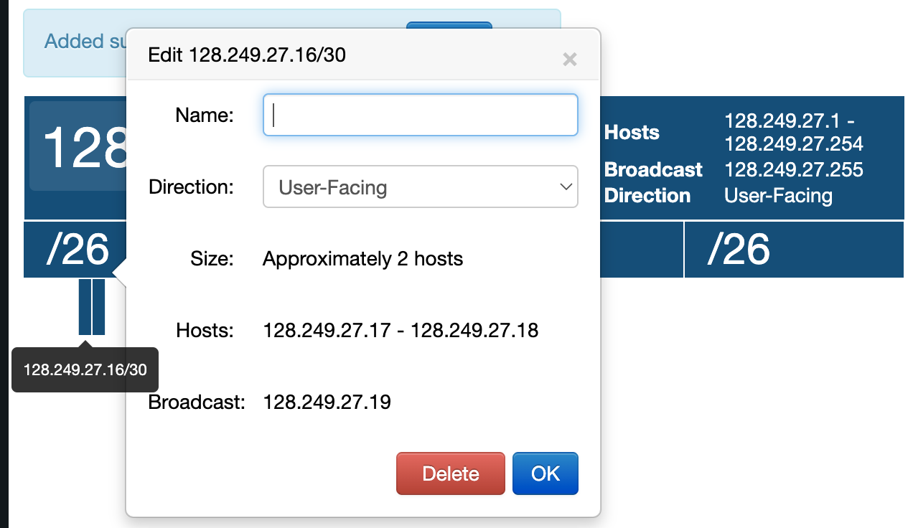

< insert your image here>

1. Go-Back-N protocol

Visit <https://media.pearsoncmg.com/aw/ecs_kurose_compnetwork_7/cw/content/interactiveanimations/go-back-n-protocol/index.html>

To access the interactive exercise for this problem.

1. Imagine that you adjust the sender window size to 10 packets (N=10). You send the first 3 packets successfully but 4th is lost, and the rest arrive at the sender. How many packets will be retransmitted when the timer expires? ____
2. The sender sends a full window of packets (N=10), packets 0 through 9, and all arrive at the receiver. An ACK is lost, number (your ID mod 10). What ACK # is lost?

After the remaining ACKs arrive, around what packet numbers will the sender’s window be positioned? Express as a range, like 1-4, 3-12, 0-14, etc.

1. How many timers run at a time?
2. N=5. You have sent packet 0-4 and all ACKs have been received successfully. Your next job is to send packets 5, 6 and 7. What is the correct sequence of events:
   1. A timer is set for packet 5, one for 6 and one for 7. Packet 6 is sent and arrives at the destination. The timer is stopped, and the process is repeated for packets 6 and 7.
   2. A timer is set for packet 5 as it is sent. All three packets are sent and delivered. The timer for 5 is stopped and no new timer is needed.
   3. A timer is set for packet 5. When the ACK for 5 is received, the timer is stopped. No new timers are needed.
   4. A timer is set for packet 5. When the ACK for 5 is received, a new timer is set for packet 6. When the ACK for 6 is received, a timer is set for packet 7 which stops when its ACK is received.

Your answer:

Include a log snapshot to justify your selection.

<insert a snapshot of your log here>

1. Consider the following network with routers u through z and the links as shown:

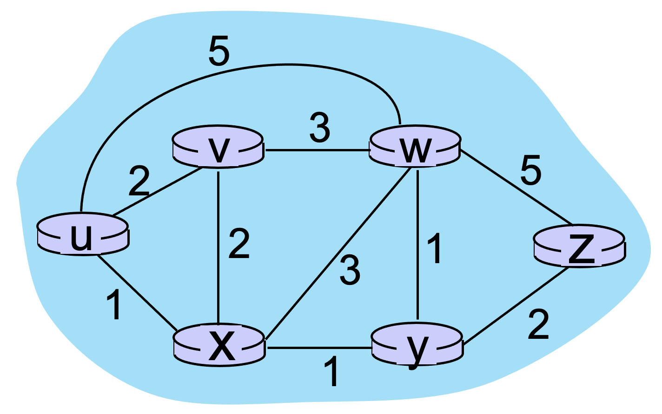

If your ID is even, add 1 to each odd weight, and subtract 1 from each even weight.

If your ID is odd, add 2 to each odd weight, and subtract 1 from each even weight.

Then using Dijkstra’s algorithm, build a least-cost routing table. If your ID ends in 00-24, build the table for router u. If 25-49, router v. If 50-74, router w. If 75-99, router x.

|  |  |  |  |  |  |  |
| --- | --- | --- | --- | --- | --- | --- |
| Step | N’ |  |  |  |  |  |
| 0 |  |  |  |  |  |  |
| 1 |  |  |  |  |  |  |
| 2 |  |  |  |  |  |  |
| 3 |  |  |  |  |  |  |
| 4 |  |  |  |  |  |  |
| 5 |  |  |  |  |  |  |

Here is an example of how to fill out a table. Start by listing your assigned router under N’ and the other routers in alphabetical order across the top.

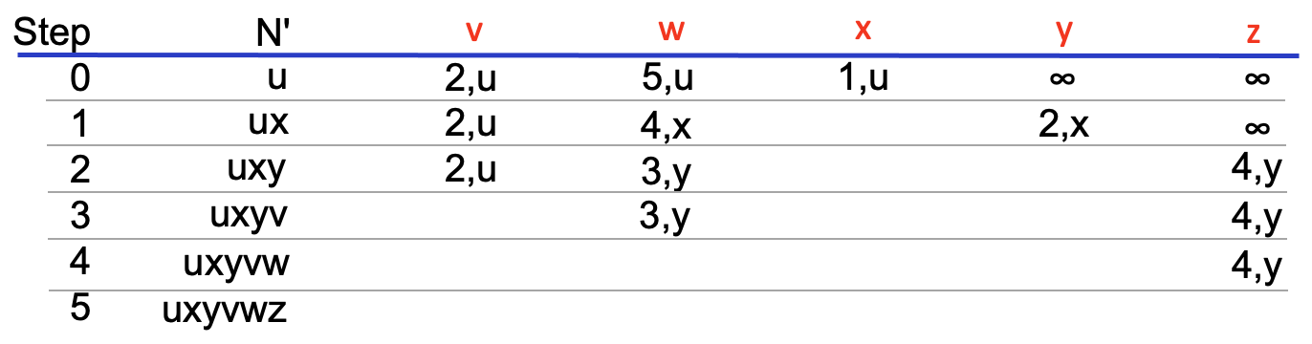

1. Refer to the diagram below, and answer the questions that follow.

* The diagram depicts six hosts, A through F, at the points on the network as shown.



* The network is on an imaginary grid 20 units across. It is the maximum cable length allowed by the standard.
* The time unit is not specified, but it is very short. With each passing time unit, a signal can travel 4 squares to the left and to the right across the grid. Therefore, if a signal is sent by B at time 0, by time 1 it will have arrived at A to the left and C to the right, like this:

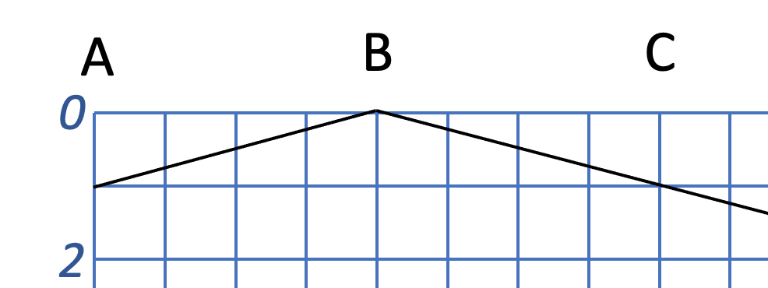

* Set a start time for your transmission. Calculate it as (ID mod 10) + 1. What time is that (1 through 10)?
* Assume Host B begins sending a signal at time you calculated.
* B immediately begins listening to the LAN to make sure the signal it hears is the signal it is sending.
* Host D begins sending the signal 2 time units after B begins.
* D immediately begins listening to the LAN to make sure the signal it hears is the signal it is sending.

1. In the full grid diagram above, draw a sloping downward line from B’s transmission starting point as far as you can in both directions. Do the same for D beginning with its starting time. Just the line, like the example above.
2. At what time will the collision occur? If it’s between two times, give a half value (e.g. 3 ½).
3. At what time will B detect the collision? If it’s between two times, give a half value (e.g. 3 ½).
4. At what time will D detect the collision? If it’s between two times, give a half value (e.g. 3 ½).
5. When does a signal first arrive at A?       Is it initially corrupted?       When does the corrupted signal first arrive?
6. When does a signal first arrive at C?       Is it initially corrupted?       When does the corrupted signal first arrive?
7. When does a signal first arrive at E?       Is it initially corrupted?       When does the corrupted signal first arrive?
8. When does a signal first arrive at F?       Is it initially corrupted?       When does the corrupted signal first arrive?
9. To detect this particular collision, at a minimum, for how long must B listen from the time it begins transmission to begin to hear the collision?
10. To detect this particular collision, at a minimum, for how long must D listen from the time it begins transmission to begin to hear the collision?
11. If A begin transmitting at time 0, what’s the maximum time at which its signal collides with another?
12. If A began transmitting at time 0, how long would it need to listen to be certain of hearing a collision from any other device on the network?       time units
13. Based on this, for our specific network, given that a station only has what it is sending to compare against what it is hearing before deciding if a collision is detected or not, how long should it continue to send a signal to be certain of hearing a collision? Remember, everyone follows the same standard, so consider the worst-case (longest) scenario for a collision to occur because all stations will have the same minimum transmission time.       time units
14. In general for a network of *m* meters, how far could a signal travel before the last one to know discovers there is a collision?
15. Given these calculations and the time when B began transmitting, at what time should it stop transmitting?
16. Below you’ll find a large version of the network timeline. Draw the same lines you did above showing how the initial part of a packet propagates across the network from B and D. Use the same start times you were given above. But this time, make each transmission a polygon that shows a continuous transmission from the start time continuing for the duration you calculted above required to send the minimum packet size. Although we don’t know the size in bits of that packet, we just calculated its duration. For example, if I determined that a packet’s minimum size required that it be transmitted for one time unit to catch all collisions, I could draw my two polygons like this:



Now it’s your turn. Draw the complete pair of polygons showing the required duration to ensure a minimum packet size is sent for each. There is room enough in the graph for both, I believe. You can color or shade to make the polygons more legible, and can print out the image, draw your polygons by hand and scan it back in. Whatever works. I strongly suggest you calculate the times where your lines will intersect the ends of the network and then use a ruler to draw straight lines.

